PROPOSAL

Alaskan Northern Lights Adventure

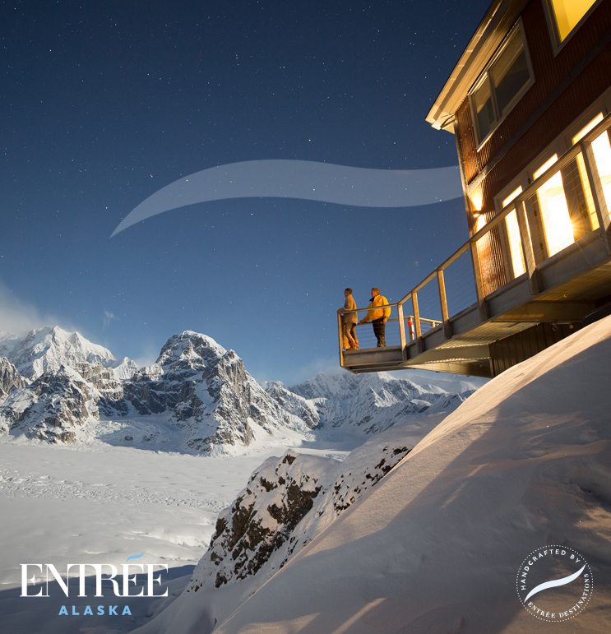
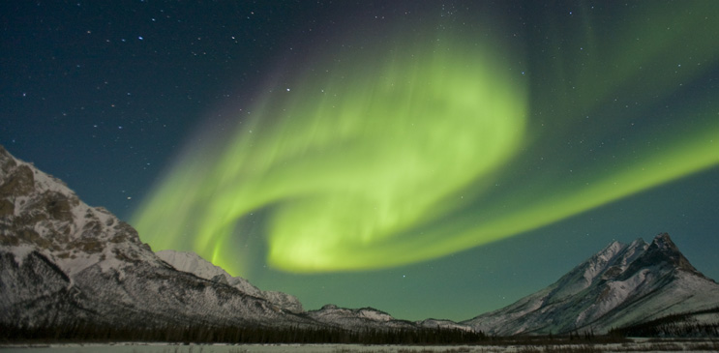

Alaskan Northern Lights Adventure

HANDCRAFT, CURATE, AND CONNECT GUARANTEE:
We guarantee that we will connect you to extraordinary people, mesmerizing destinations, and unforgettable experiences.
We guarantee that your trip will be delivered with thoughtfulness, imagination, and meticulous planning.
We guarantee that if, on rare occasion, things do not go as planned, we will shine for you and support you 24-7 until you are delighted with our prompt solutions.
We guarantee to provide you with premium service.

SUMMARY OF TERMS & CONDITIONS:
Prices are stated in USD and include all taxes. To secure your booking we require a minimum 50% non-refundable deposit at time of booking. The 50% non-refundable final payment is due at or before 91 days prior to tour departure. This payment must be made in American funds and may be made by wire transfer.

Cancellations must be received in writing and the following cancellation terms apply: Received after deposit up to 91 days prior to departure; 50% of total tour cost. Received 90 days or less prior to departure; 100% of total tour cost.

*Please refer to the end of this proposal for our full terms and conditions.

All trips that we operate include a $5 carbon surcharge per person to offset the carbon footprint of an average Entrée Alaska journey. With these funds, we purchase Gold Standard carbon offset credits from Less Emissions to neutralize your carbon footprint at the end of each calendar year. To learn more, visit www.less.ca.

PROPOSED ITINERARY
Day 1
Meals Today: Lunch, Dinner

Arrive Anchorage, Alaska

Private transfer from the Anchorage Airport to Merrill Field

Scheduled helicopter flight from Anchorage to Sheldon Chalet (1-hour, 15-minutes).
Luggage restriction: 16 kg (35-lbs) per person

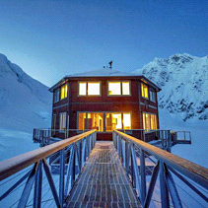 | 3-night stay at Sheldon Chalet  Chalet Buyout  All meals, soft beverages, premium wine pairings with dinner, and outdoor clothing rental are included during your stay.  Perched at nearly 6000 feet (1829 meters) upon Denali’s Ruth Glacier deep inside Denali National Park is the Sheldon Family’s private property – Sheldon Chalet. An engineering marvel, this luxury destination was built to showcase the stunning views that surround it and to provide guests with an extraordinary, one-of-a-kind experience. The chalet offers curated guided adventures, exquisite cuisine prepared by a private chef, accompanied by fine wines, and concierge service to make your stay as wonderful as possible. The chalet also features a sauna with a view of the summit, a large observation deck and viewing station to drink in the magnificent panorama and aurora borealis, an open kitchen, dining, and living area with fireplace, and five guest rooms with plush cozy bedding and two full bathrooms.
Day 2-3
Meals Today: Breakfast, Lunch, Dinner

Lodge based adventures at Sheldon Chalet.  The Sheldon Chalet offers a place to experience a multitude of awe-filled moments, a silence so grand and peaceful and views that leave you breathless, all in warm luxe comfort never seen before on Denali. During your stay at the chalet, you will be able to enjoy the following activities:  - Aurora viewing  - Star and meteor shower gazing  - Glacier trekking  - Snow cavern spelunking  - Sledding  - Soaking in the sauna  - Gourmet glacier picnic  - Rappelling  - Crevasse exploration | 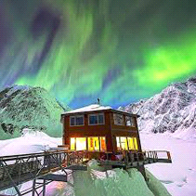
Day 4
Meals Today: Breakfast, Lunch

Scheduled helicopter flight from Sheldon Chalet to Talkeetna (45-minutes).
Luggage restriction: 16 kg (35-lbs) per person

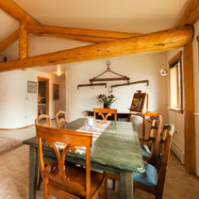 | 2-night stay at Belle's Cabin  Three Bedroom Cabin  Located right on Main Street in beautiful downtown Talkeetna, and within steps to all major attractions, Belle’s Cabin is a perfect place to stay. Dating back to 1918, Belle’s Cabin was originally owned by Belle McDonald, an indomitable, hard working trading post operator who lived in Talkeetna for over 40 years. A large addition to the cabin was recently added and designed with modern standards which complements the original historic structure. Surrounded by lush and lovely private gardens, the cabin comprises of two nicely appointed bedrooms with queen beds, a third bedroom with a bunkbed and twin bed, two bathrooms, a full kitchen complete with modern appliances, and a spacious dining and living area.  Beds: Two Queen beds, one Double, one Twin, & one bunkbed
Day 5
Meals Today: Breakfast, Lunch, Dinner

Fun Adventures in Talkeetna. Based on timing and clients desires here are some options for the day:  - dog sledding  - winter "fat tire" biking  - xc skiing  - snow machining  - Denali Brewing tour and tasting room  - museum and local history tour - Talkeetna town tour walkabout, museum, convo with Robert | 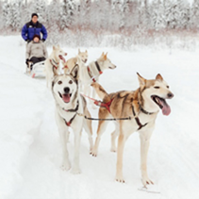
Day 6
Meals Today: Breakfast, Lunch

You will have time for more fun adventures today prior to departing Talkeetna for Anchorage and the Anchorage Airport.

Private Scenic Transfer from Talkeetna to Anchorage and the Anchorage Airport (3-hours).

We look forward to serving you.

Other Inclusions:
> Final documentation package via e-mail (approximately 14-21 days prior to travel).
> Overnight accommodations as outlined in itinerary.
> All ground transportation as outlined in itinerary.
> All internal air flights via small plane as noted in the itinerary.
> Private and/or shared tours as outlined in itinerary.
> All meals specified preceding each day’s description.
> All applicable taxes.

Not Included:
> Airfare to Anchorage and from Anchorage home.
> Gratuities for lodge staff, tour guides, drivers, pilots, customer service staff, etc.
> Alcoholic beverages except as indicated in the above itinerary.
> Fishing licenses ($25-70 per person for guests 16 and older), fish processing, or shipping.
> All items of a personal nature and any other items not specifically included in the itinerary.
> Telephone, minibar, spa treatments, incidentals, etc. (unless specifically mentioned in the itinerary)
> Excess luggage charges on air segments.
> Airport porterage.

